**Static Routing Using Packet Tracer**

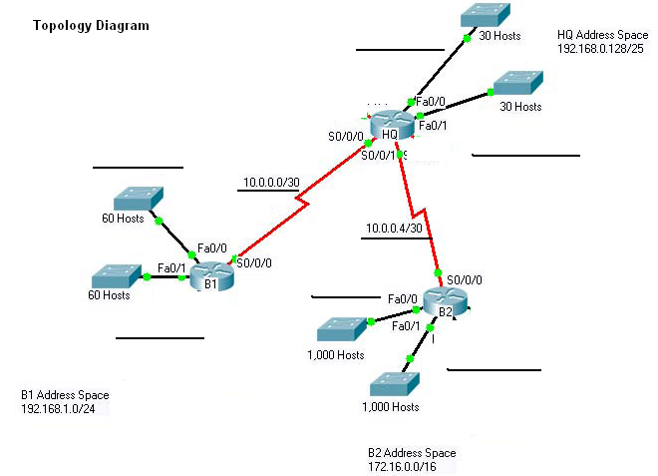

**Task 1: Addressing Table**

|  |  |  |  |
| --- | --- | --- | --- |
| **Device** | **Interface** | **IP address** | **Subnet Mask** |
| **HQ** | **Fa 0** | **192.168.0.129/27** | **255.255.255.224** |
| **Fa 1** | **192.168.0.161/27** | **255.255.255.224** |
| **Serial 2** | **10.0.0.1** | **255.255.255.252** |
| **Serial 3** | **10.0.0.5** | **255.255.255.252** |
| **B1** | **Fa1** | **192.168.1.1/26** | **255.255.255.192** |
| **Fa2** | **192.168.1.65/26** | **255.255.255.192** |
| **Serial 2** | **10.0.0.2** | **255.255.255.252** |
| **B2** | **Fa1** | **172.16.0.1/22** | **255.255.252.0** |
| **Fa2** | **172.16.4.1/22** | **255.255.252.0** |
| **Serial 3** | **10.0.0.6** | **255.255.255.252** |

**Task 2: Subnet Information**

|  |  |  |  |  |
| --- | --- | --- | --- | --- |
| **Subnet Number** | **Subnet Address** | **First Host Address** | **Last Host Address** | **Gateway Address** |
| **1**  **HQ** | **192.168.0.128/27** | **192.168.0.129/27** | **192.168.0.158/27** | **192.168.0.129/27** |
| **2**  **HQ** | **192.168.0.160/27** | **192.168.0.161/27** | **192.168.0.190/27** | **192.168.0.161/27** |
| **3**  **B1** | **192.168.1.0/26** | **192.168.1.1/26** | **192.168.1.62/26** | **192.168.1.1/26** |
| **4 B1** | **192.168.1.64/26** | **192.168.1.65/26** | **192.168.1.126/26** | **192.168.1.65/26** |
| **5**  **B2** | **172.16.0.0/22** | **172.16.0.1/22** | **172.16.3.254/22** | **172.16.0.1/22** |
| **6 B2** | **172.16.4.0/22** | **172.16.4.1/22** | **172.16.7.254/22** | **172.16.4.1/22** |
| **7** | **10.0.0.0** | **10.0.0.1** | **10.0.0.2** |  |
| **8** | **10.0.0.4** | **10.0.0.5** | **10.0.0.6** |  |

**Task 3: Static Routing Table for Router**

|  |  |  |  |
| --- | --- | --- | --- |
| **Router** | **Unknown Network Address** | **Mask Address** | **Next Hop** |
| **HQ** | **192.168.1.0/26** | **255.255.255.192** | **10.0.0.2** |
| **192.168.1.64/26** | **255.255.255.192** | **10.0.0.2** |
| **172.16.0.0/22** | **255.255.252.0** | **10.0.0.6** |
| **172.16.4.0/22** | **255.255.252.0** | **10.0.0.6** |
| **B1** | **192.168.0.128/27** | **255.255.255.224** | **10.0.0.1** |
| **192.168.0.160/27** | **255.255.255.224** | **10.0.0.1** |
| **172.16.0.0/22** | **255.255.252.0** | **10.0.0.1** |
| **172.16.4.0/22** | **255.255.252.0** | **10.0.0.1** |
| **10.0.0.4/30** | **255.255.255.252** | **10.0.0.1** |
| B2 | **192.168.0.128/27** | **255.255.255.224** | **10.0.0.5** |
| **192.168.0.160/27** | **255.255.255.224** | **10.0.0.5** |
| **192.168.1.0/26** | **255.255.255.192** | **10.0.0.5** |
| **192.168.1.64/26** | **255.255.255.192** | **10.0.0.5** |
| **10.0.0.0/30** | **255.255.255.252** | **10.0.0.5** |